**NAME:** - ANSHUL SAINI  
**MAIL:** - [sainianshul7565@gmail.com](mailto:sainianshul7565@gmail.com)

**User ID**: - 34732

**Date: -** 07/08/2025

**Batch: -** DWS_B5_25VID2550

**Topic Assignment: -**

* Intunewin conversion - Compatible version to upload to Intune
* Interactive and Non-Interactive Applications
* Required and Available App assignments
* Process Flow for an Application on Windows client via IME service. (From Polling to detection, to installation, to detection and toast notifications as success/failure)
* Registries with respect to LOB and Win32Apps
* Specific Registries with Application GUID which give you the status of Installation/Uninstallation.
* **Intunewin conversion - Compatible version to upload to Intune:**

To deploy a Win32 app via Intune, use the Microsoft Win32 Content Prep Tool to convert your app’s installation files into a .intunewin package. Ensure devices run Windows 10 version 1607 or later and are enrolled in Intune. First, gather all necessary app files. Then, run IntuneWinAppUtil.exe to generate the .intunewin file. Upload this file in the Intune admin center under Windows apps (Win32). Keep the package size under 8 GB, and provide silent install and uninstall command-line arguments. Proper packaging and enrollment are essential for successful deployment.

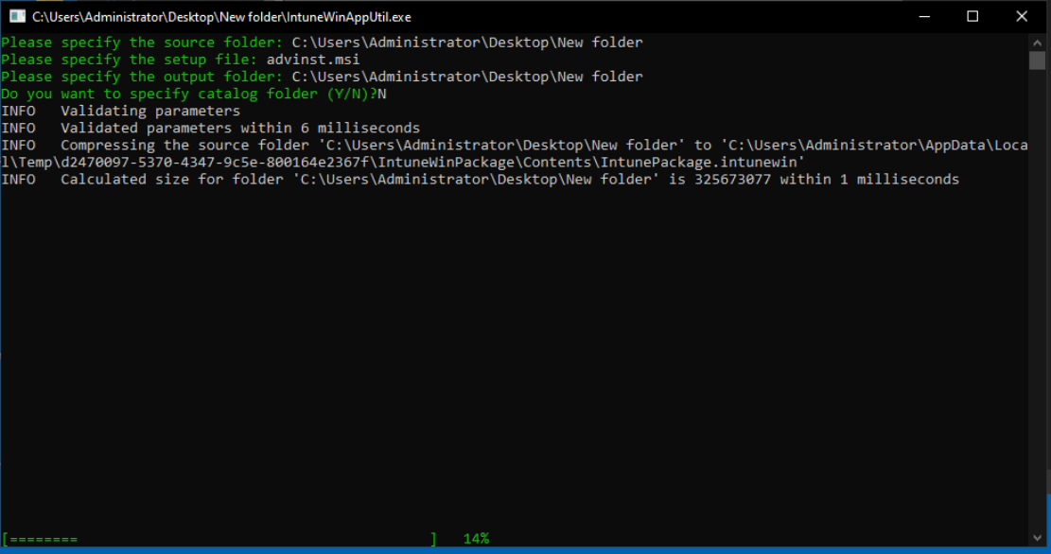**Practice Activity:** -



* **Interactive and Non-Interactive Applications:**

Interactive applications need users to click, type, or choose options to work, like web browsers or games. They have a visible screen called a GUI. Non-interactive applications run quietly in the background without showing anything, doing tasks like updates or backups. They work automatically without needing user input.

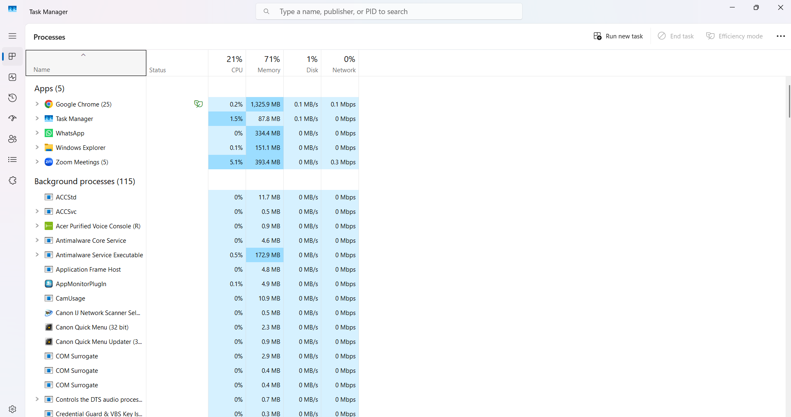**Practice Activity: -**

* **Required and Available App assignments:**

To sync a device after app assignments in Microsoft Intune, you can use several methods depending on your device type. For Windows and Android devices, the Company Portal app is a common tool. On Windows, open the Company Portal, go to *Settings*, and select *Sync*. You can also right-click the Company Portal icon from the taskbar or Start menu and choose *Sync this device*. Another way is through Windows Settings: go to *Accounts > Access work or school*, select your work account, click *Info*, and then choose *Sync*. For Android devices, open the Company Portal app, go to *Settings*, and tap *Sync*. Alternatively, IT admins can initiate a sync remotely using the Intune admin center. After signing in, navigate to *Devices > All devices*, select the device, open the *Overview* pane, and click *Sync*, confirming when prompted. Syncing ensures that the latest app assignments, policies, and configurations are applied to the device. The process may take a few minutes, and users might receive notifications about updates or changes. Regular syncing helps maintain compliance and ensures devices are up to date with organizational requirements. It’s a key step in managing devices effectively within an enterprise environment using Intune.

**Practice Activity: -**

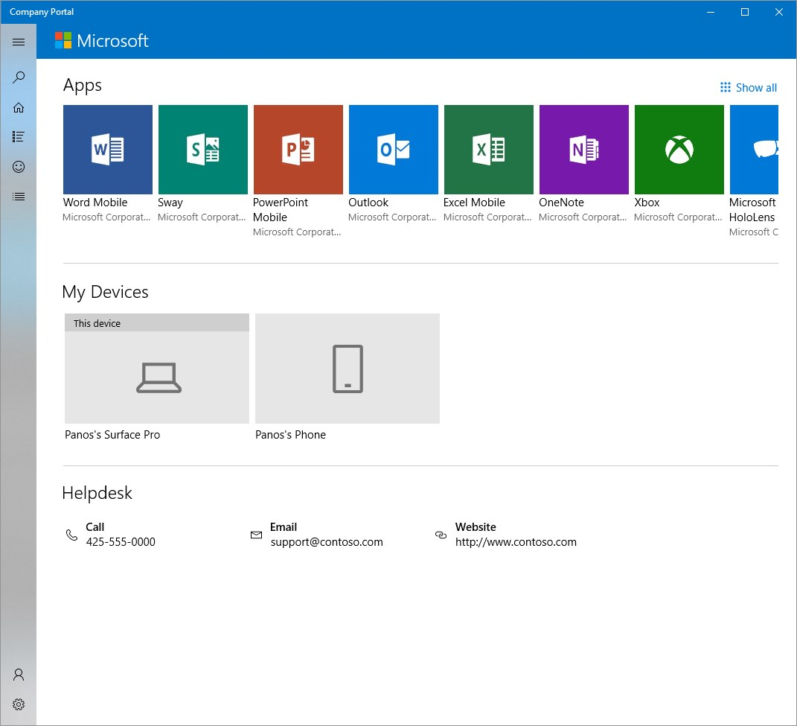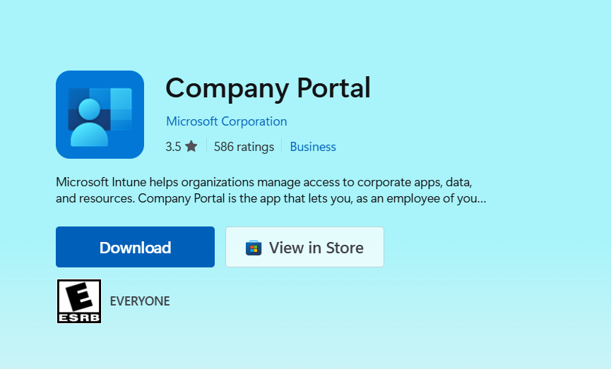

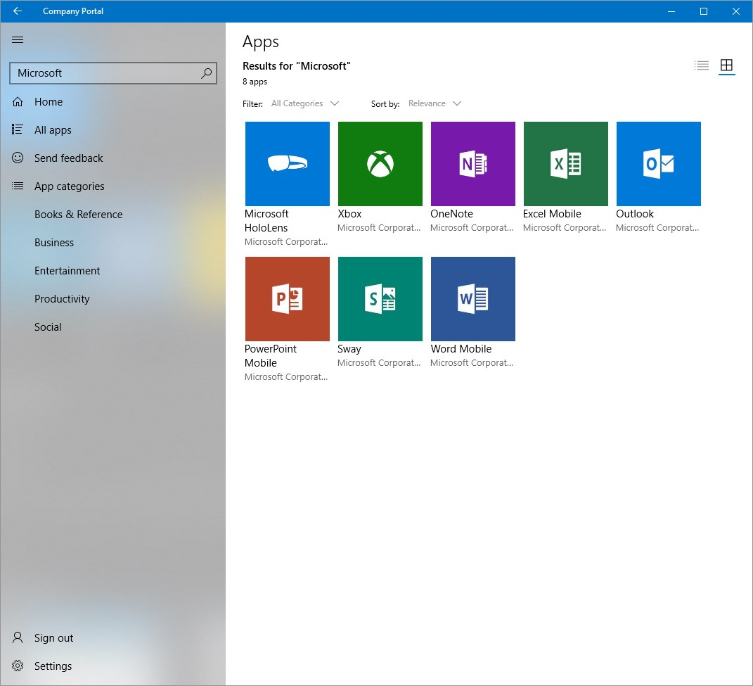

* **Process Flow for an Application on Windows client via IME service. (From Polling to detection, to installation, to detection and toast notifications as success/failure):**

The Intune Management Extension (IME) service deploys applications to Windows clients through a structured flow: polling, detection, installation, and notification. IME regularly checks Intune for new app assignments. Before installing, it uses detection rules to see if the app already exists. If not, it downloads the app package, runs the installer, and monitors progress. After installation, detection rules confirm success. Based on results, users receive toast notifications showing success or failure. These alerts are customizable and provide instant feedback. If required by policy, the device may restart to apply changes. This process ensures reliable app deployment and user awareness.

* **Specific Registries with Application GUID which give you the status of Installation/Uninstallation:**

To check if an app is installed or uninstalled on Windows, you can look in the registry. For all users, go to HKLM\SOFTWARE\Microsoft\Windows\CurrentVersion\Uninstall. For the current user only, check HKCU\SOFTWARE\Microsoft\Windows\CurrentVersion\Uninstall. Inside these folders, each app has its own subfolder, which may show the app’s name or a unique code called a GUID. This GUID is a special code used to identify and uninstall the app. To uninstall, use the command msiexec.exe /x {GUID} /QN, which removes the app silently. You can also save a log of the uninstall process.

Log files help track what happens in your system or apps. They show the time of events, the type (like errors or warnings), how serious they are, and what happened. Each event has a unique ID and is grouped into categories like system, application, or security. These logs are useful for fixing problems and understanding how your system behaves.

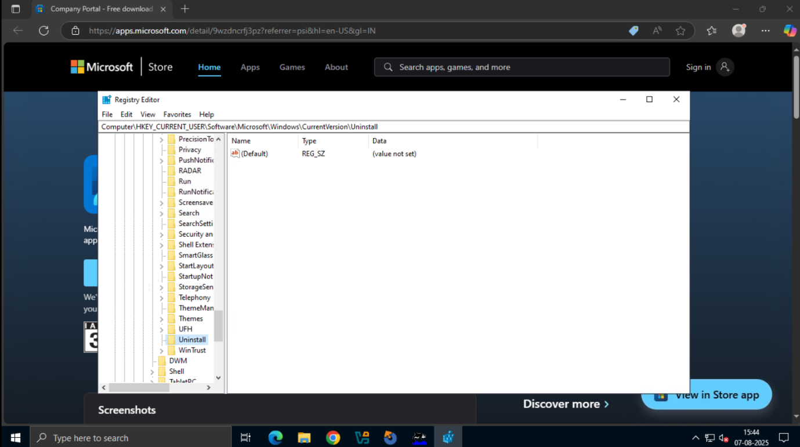**Practice Activity:** -

* **Registries with respect to LOB and Win32Apps:**

In Windows, the Registry is like a big database that stores important settings for the system and apps. Both Line-of-Business (LOB) apps and Win32 apps use the Registry to save information like user preferences, app settings, and installation status. LOB apps are usually custom-made for a company’s specific needs, while Win32 apps are traditional Windows programs. Microsoft Intune, a tool used to manage devices and apps, also uses the Registry. It checks Registry entries to see if an app is installed and can apply certain settings based on what it finds. The Registry is organized into “keys” (like folders) and “values” (which hold the actual data). Apps read and write to these keys to work properly. Editing the Registry can help fix problems or change how things work, but it should be done carefully. Wrong changes can cause system issues, so it’s best to follow trusted steps or use tools like Intune.

**Practice Activity: -**



